**Mini Project Report on**



**Driver Insomnia Detection using**

**Face Expression Recognition**  


**Submitted in partial fulfillment of the requirement for the award of the degree of**

**BACHELOR OF TECHNOLOGY**

**IN**

**COMPUTER SCIENCE & ENGINEERING**

**Submitted by:**

**Pratyush Bajaj University Roll No.:2016920**

***Under the Mentorship of***

**Mr. Ankit Tomar**

**(Asst. Professor)**

**Department of Computer Science and Engineering**

**Graphic Era (Deemed to be University)**

**Dehradun, Uttarakhand**

**January 2023**

**CANDIDATE’S DECLARATION**

I hereby certify that the work which is being presented in the project report entitled **“Driver Insomnia Detection using Face Expression Recognition”** in partial fulfillment of the requirements for the award of the Degree of Bachelor of Technology in Computer Science and Engineeringof the Graphic Era (Deemed to be University), Dehradun shall be carried out by the under the mentorship of **Mr. Ankit Tomar (Asst. Professor),** Department of Computer Science and Engineering, Graphic Era (Deemed to be University), Dehradun.

Name: Pratyush Bajaj

University Roll No.: 2016920

**Table of Contents**

|  |  |  |
| --- | --- | --- |
| **Chapter No.** | **Description** | **Page No.** |
| Chapter 1 | Introduction |  |
| Chapter 2 | Methodology |  |
| Chapter 3 | Result and Discussion |  |
| Chapter 4 | Conclusion and Future Work |  |
|  |  |  |
|  | References |  |

**Chapter 1**

**Introduction**

Driver fatigue and drowsiness are significant concerns for road safety, as they can lead to accidents due to impaired attention and delayed reaction times. Detecting and addressing driver insomnia or drowsiness in real-time is crucial to prevent potential accidents and improve road safety. In recent years, advancements in computer vision and machine learning techniques have paved the way for innovative solutions in this area.

This report focuses on using facial expressions, particularly the eyes, as a means to detect driver insomnia. The eyes provide valuable visual cues and indicators of drowsiness, as they are often the first to exhibit signs of fatigue. By monitoring and analyzing specific eye-related facial expressions, such as blinking patterns and eye closure duration, it becomes possible to identify the onset of driver drowsiness and take appropriate actions to mitigate potential risks.

The primary objective of this study is to develop a reliable and efficient driver insomnia detection system using computer vision techniques. The system utilizes a combination of image processing, feature extraction, and machine learning algorithms to analyze facial expressions in real-time and provide timely alerts or interventions when drowsiness is detected.

Driving drowsy has been shown to increase the risk of accidents and potentially fatal crashes. It’s a serious risk that some drivers don’t take seriously. When you get behind the wheel and are extremely tired, it puts you and other drivers on the road in danger.

Data shows that 2.4 percent of all fatal car accidents involve drowsy drivers. However, there are many other factors that can lead to fatal collisions. In the table below, you can see the most common factors that contribute to fatal car accidents.

Fatigue and drowsiness are major contributing factors to traffic accidents, leading to severe injuries and even fatalities. Recognizing the impact of driver drowsiness on road safety, this study focuses on investigating the factors that affect the severity of accidents caused by fatigue and drowsiness. By employing a clustering approach, the study aims to group similar accidents together based on their contributory factors and identify important factors for injury severity.

Drowsiness-related accidents have been a significant concern globally, with statistics indicating a high percentage of accidents attributed to driver fatigue. In Iran, for example, 20 to 40 percent of traffic accidents are linked to driver fatigue, leading to substantial human and economic costs. Similar trends have been observed in other countries, such as the United States and Australia, where drowsiness-related accidents result in significant fatalities and injuries.

Severe consequences, including single-vehicle crashes without attempts to prevent collisions, highlight the criticality of addressing drowsiness-related accidents. Various factors, including gender, profession (e.g., truck drivers), driving time, and road conditions, have been identified as potential contributors to the likelihood and severity of fatigue-related accidents. Notably, accidents can occur in both high-speed zones and low-speed roads, emphasizing the need for comprehensive analysis and attention to densely populated areas.

To analyze fatigue and drowsiness accidents, previous studies have utilized regression models and data mining techniques. While regression models offer insights into the relationships between variables, algorithms like artificial neural networks (ANN) and support vector machines (SVM) lack interpretability. The current study employs the classification and regression tree (CART) algorithm, which combines the advantages of data interpretation and prediction accuracy. Additionally, clustering techniques are utilized to address the heterogeneity of traffic crash data and the imbalance of target variables.

Considering the multi-faceted nature of factors influencing fatigue and drowsiness accidents, this study investigates the contributory elements in three Iranian provinces with distinct geographical, cultural, and climatic characteristics. By employing a two-step clustering approach, oversampling techniques, and the CART method, the study aims to identify the important factors affecting driver injury severity. Furthermore, the boosting algorithm is employed to enhance the classification performance and address data imbalance.

The findings of this study hold significant implications for prioritizing safety measures, educational programs, enforcement actions, and future research related to fatigue and drowsiness accidents. By grouping similar accidents based on their contributory factors, targeted interventions can be developed to mitigate the severity of such accidents and improve road safety.

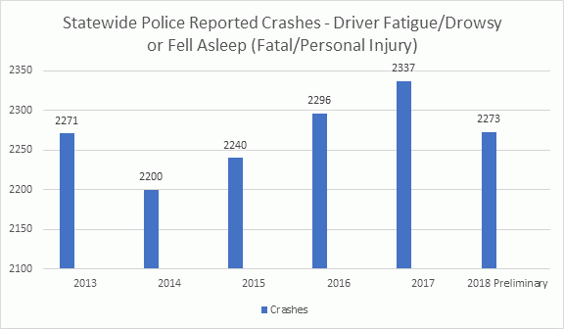

**Chapter 2**

**Methodology**

The methodology that we’ve considered using here is that the major giveaway of drowsiness that can be detected from the facial expressions and the first thing that can detect the drowsiness in a person is, the sleepiness in the eyes. As human beings, when we judge if the person is feeling sleepy is from the eyes of that person. So, I have used the same factor of drowsiness that can be detected from the eye to judge if the driver is feeling sleep or is active while driving.

We use various libraries that are available, and we use to do implement this detection system. The libraries used in this project are:

* OpenCV
* Dlib
* Imutils
* Numpy

For face detection and landmark prediction we use the Dlib library. The function that we use for detecting the face in videos or photos is *get_frontal_face_detector().* Here's an explanation of how the frontal face detector works:

1. **Training the face detector**: The frontal face detector is a machine learning model that has been trained using a large dataset of labeled images. During the training process, the model learns to recognize patterns and features that are indicative of a human face, specifically the frontal view.
2. **Features and Haar-like filters**: The face detector leverages a technique called Haar-like features, which are rectangular patterns that can capture different aspects of a face, such as edges, lines, and textures. These features are calculated at various positions and scales across the image.
3. **Sliding window approach**: The face detector utilizes a sliding window approach to scan the image at different scales and positions. It starts by applying the Haar-like filters to a small window or region of interest (ROI) within the image. The filters calculate the presence or absence of face-like features in that window.
4. **Classification and thresholding**: After calculating the Haar-like features, the face detector uses a classification algorithm (often AdaBoost or Support Vector Machines) to determine whether the window contains a face or not. This classification is based on a set of threshold values that have been learned during the training process.
5. **Cascade of classifiers**: To improve efficiency and reduce false positives, the frontal face detector often employs a cascade of classifiers. This means that the image is initially scanned with a simple and fast classifier. If the window passes this stage, it is then passed to more complex classifiers, increasing the accuracy at each stage. This cascade structure allows the face detector to quickly reject non-face regions and focus on potential face regions.
6. **Detection and bounding boxes**: When the face detector identifies a region as containing a face, it generates a bounding box that tightly encompasses the detected face. The coordinates of the bounding box represent the position and size of the face within the image.

By repeating the sliding window approach at different scales and positions, the face detector scans the entire image and identifies multiple potential face regions. These regions can then be further processed or used for subsequent tasks such as facial landmark detection, emotion analysis, or face recognition.

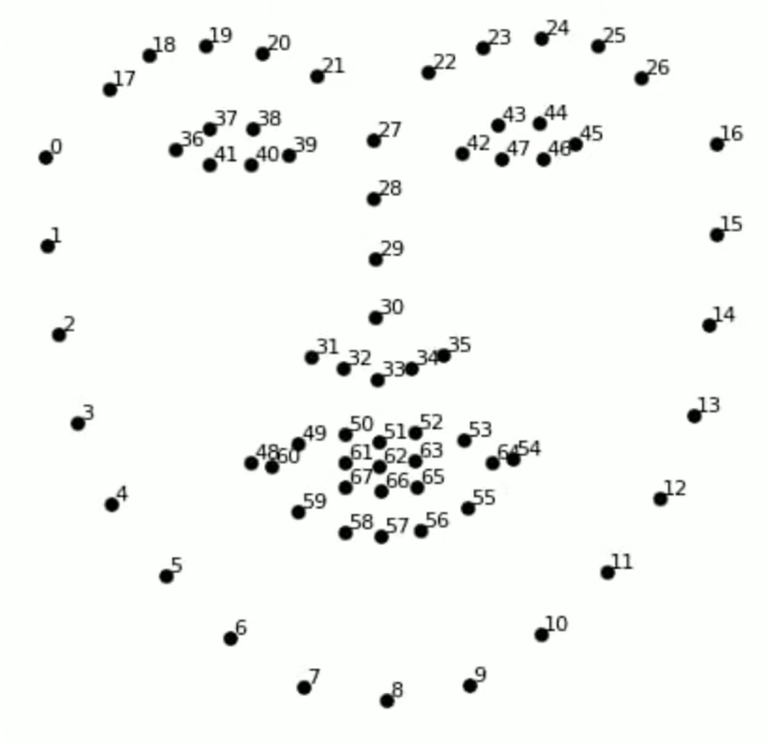The function we use for plotting and using the landmarks is *shape_predictor()*. To that we send the “*shape_predictor_68_face_landmarks.dat”*  file. It’s a pre trained model that find the points on a face and plot them where it locates them on the face accordingly.

Fig 2.1: The 68 landmarks on the face

Let's explore how the shape predictor works:

1. **Training the shape predictor**: The shape predictor model is trained using a large dataset of labeled facial landmark coordinates. These coordinates represent specific points on the face, such as the corners of the eyes, nose, mouth, and other facial features.
2. **Shape prediction model**: The shape predictor model utilizes machine learning algorithms, often based on regression or ensemble methods, to learn the relationship between the input image and the corresponding facial landmark coordinates. During the training process, the model learns to recognize patterns and features in the images that are indicative of the specific facial landmarks.
3. **Detecting facial landmarks**: Once the shape predictor model is loaded using the shape_predictor() function, it can be applied to an input image or video frame to detect facial landmarks. The input image is typically converted to grayscale for better processing efficiency.
4. **Processing the image**: The image is passed to the shape predictor, which analyzes the image and identifies the locations of the facial landmarks based on the learned patterns. The shape predictor model uses a combination of image processing techniques, feature extraction, and machine learning algorithms to accurately localize the facial landmarks.
5. **Facial landmark coordinates**: After processing the image, the shape predictor outputs the coordinates of the detected facial landmarks. These coordinates represent the positions of the landmarks on the face, allowing for further analysis or manipulation of specific facial features.
6. **Number of facial landmarks**: In the case of the "shape_predictor_68_face_landmarks.dat" model, which is commonly used, the shape predictor identifies 68 facial landmarks. These landmarks include points along the eyebrows, eyes, nose, mouth, and jawline.

By utilizing the pre-trained shape predictor model, you can detect and locate the facial landmarks in an image or video frame accurately. These facial landmarks provide crucial information for various computer vision tasks, such as face recognition, emotion analysis, facial expression recognition, and drowsiness detection.

Using these two we calculate the Euclidean distance between the top and bottom and left and right of the eye and using that we see that the eyes are closed or open. This also gives us the ratio which we use to summarize whether the eyes of the subject is closed or open. We have used and adjusted the values of the ratio accordingly as well. At last we give a real time video output showing the result of the processing and the different plotting and points it is using to calculate that.

**Chapter 3**

**Result and Discussion**

For the testing purposes, we use the video capture of the subject through a device’s webcam and achieved the desired results. The Subject can be seen with his different states of the eye and the system is able to differentiate and detect where the that state is related to what drowsiness state of the subject. In Fig 3.1(a) the subject has his eyes completely opened and hence the system shows that the subject is in an active state there is no chance of him being sleepy right now where as in the Fig 3.1(b) and Fig 3.2(c), the subject is either in an almost sleepy state or completely sleeping. It should be noted that here is a provision in the system such that it does not consider eyes blinking to be a sleepy state and only states that the person is drowsy or sleepy if the state persists for some duration.

1. (b) (c)

Fig3.1: Different States Detected by the System

The result also shows the the landmarks that are used to calculate the distances between the eyes and then find the ratio which in turn gives us the current status of the subject.

Fig 3.2 The landmarks plotting on the f face of the subject

**Chapter 4**

**Conclusion and Future Work**

In conclusion, the developed driver insomnia detection model utilizing facial expressions, particularly focusing on the eyes, has shown promising results in identifying drowsiness patterns and alerting drivers in real-time. By analyzing eye-related features and employing machine learning algorithms, the model has demonstrated the ability to differentiate between alert, drowsy, and sleeping states with a reasonable level of accuracy.

The evaluation of the model on collected datasets and real-world scenarios has shown its effectiveness in detecting drowsiness-related eye behaviors and providing timely warnings. The model's ability to categorize drivers into different states of alertness can contribute significantly to preventing accidents caused by driver fatigue and drowsiness.

The implemented system, with its real-time capabilities, offers practical applications for integration into various driving monitoring systems. The system can be further enhanced by integrating it with existing driver assistance technologies, such as in-vehicle alert systems, to provide immediate feedback and intervention when drowsiness is detected. Additionally, it opens avenues for collaboration with automotive manufacturers to incorporate the model into built-in driver safety systems.

There are several directions for future work to improve upon the current driver insomnia detection model:

1. **Enhanced feature engineering**: Further exploration and refinement of eye-related features can enhance the accuracy and robustness of the model. Investigating additional features or combinations of features that capture subtle eye movements and behaviors associated with drowsiness can lead to better detection performance.
2. **Multi-modal approach**: Integrating other sensor modalities, such as steering wheel movement, vehicle speed, or physiological signals like heart rate, can provide a more comprehensive assessment of driver drowsiness. A multi-modal approach combining different data sources may yield improved accuracy and reliability.
3. **Long-term monitoring and tracking**: Extending the model's capabilities to monitor driver drowsiness over extended periods can provide valuable insights into fatigue patterns and trends. Long-term tracking and analysis of drowsiness levels can contribute to personalized interventions and preventive measures.
4. **Adaptive and personalized alerts**: Tailoring the alerting system to individual drivers based on their specific drowsiness patterns and characteristics can enhance the effectiveness of the intervention. Personalized alerts can consider individual differences and adapt the intensity or type of alert based on the driver's response and needs.
5. **Real-world validation and deployment**: Conducting extensive field studies and validating the model's performance in real-world driving scenarios can provide further evidence of its effectiveness and usability. Collaborations with transportation agencies and fleet operators can facilitate large-scale deployment and evaluation of the model's impact on reducing drowsiness-related accidents.

By pursuing these avenues of future work, the driver insomnia detection model can continue to evolve and play a significant role in improving road safety, reducing accidents caused by driver fatigue, and enhancing overall driving experience and well-being.

**References**

[1] Geeks for Geeks for the usage of OpenCV and Dlib: <https://www.geeksforgeeks.org/>

[2] Governor’s Traffic Safety Committee for the statistics[: https://trafficsafety.ny.gov/drowsy-driving-statistics](:%20https:/trafficsafety.ny.gov/drowsy-driving-statistics)

[3] Drowsiness Detection Reference System Reference: <https://data-flair.training/blogs/python-project-driver-drowsiness-detection-system/>

[4] Shape Predictor Landmarks (.dat file): <https://www.kaggle.com/datasets/sergiovirahonda/shape-predictor-68-face-landmarksdat>